Reusable Workflows in GitHub Actions
A Reusable Workflow is a GitHub Actions workflow that you write once and allow other workflows/repositories to call and reuse.
The main purpose is to avoid copy-pasting the same CI/CD YAML into many repositories.
1. The problem without Reusable Workflows
Suppose you have:
Microservice A → GitHub Repo A → pipeline.yml
Microservice B → GitHub Repo B → pipeline.yml
Microservice C → GitHub Repo C → pipeline.yml
...
Microservice T → GitHub Repo T → pipeline.yml
And every repository has:
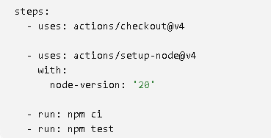
Now imagine the company says:
"Change Node.js from 20 to 22."
You potentially have to modify 20 workflow files.
SOLUTION IS TO USE REUSABLE WORKFLOW
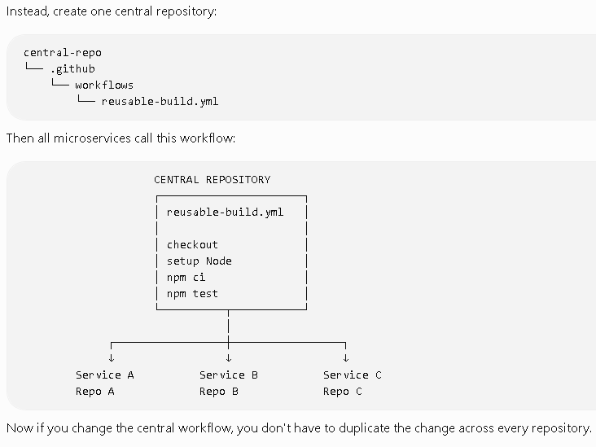

Lab: GitHub Actions workflow_call
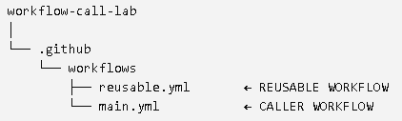
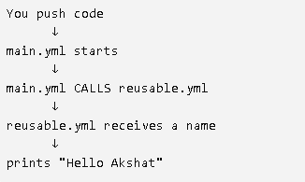
STEP 1 — Create a GitHub Repository
Go to GitHub and create a new repository.
Repository name:
workflow-call-lab
You don't need to add any code.
After creating it, your repository should look approximately like:
workflow-call-lab
STEP 2 — Create the .github Folder
Inside your repository, click:
Add file → Create new file
For the filename, enter:
.github/workflows/reusable.yml
Notice that you are creating two folders:
.github
↓
workflows
↓
reusable.yml
So the complete path is:
.github/workflows/reusable.yml
STEP 3 — Put This Code in reusable.yml
This is our REUSABLE WORKFLOW.
###
name: My Reusable Workflow
on:
workflow_call:
inputs:
username:
required: true
type: string
jobs:
say-hello:
runs-on: ubuntu-latest
steps:
- name: Say Hello
run: echo "Hello ${{ inputs.username }}"
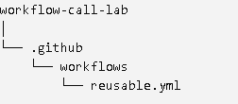
STEP 4 — Create the Second File
Now create another file.
Click:
Add file → Create new file
Filename:
.github/workflows/main.yml
So now your repository will contain:
workflow-call-lab
│
└── .github
└── workflows
├── reusable.yml
└── main.yml
STEP 5 — Put This Code in main.yml
name: Main Workflow
on:
push:
jobs:
call-reusable-workflow:
uses: ./.github/workflows/reusable.yml
with:
username: "Akshat"

